This application must be run locally using the local IP address. Users must install a code editor (Visual Studio Code was used to develop the project), XAMPP from <https://www.apachefriends.org/download.html> to run the MySQL database and HeidiSQL from https://www.heidisql.com/download.php to view the database. The database must be set up and started before starting the application. The database could be started by clicking the ‘Start’ button of the ‘MySQL’ module from the XAMPP control panel. The database credentials must be entered in the .env file, which are as follows.

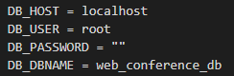

A database dump will be included in the CD that will need to be used in the MySQL database as there are the required tables and other information that are required for the application to run successfully.

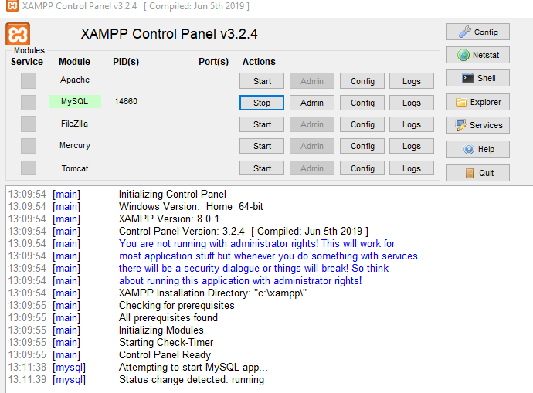

Once the database is running, HeidiSQL must be opened, with details as shown in the image below. The user and password must match the details in the .env file. Once all details are as below, a session may be opened by clicking ‘Open’.

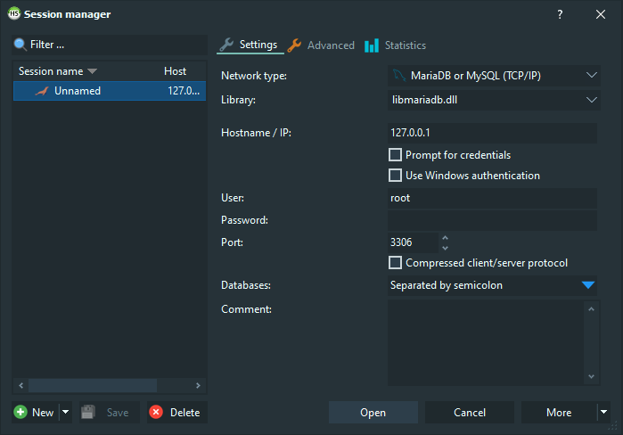

A new database must be created one the session is opened, which may be done by right-clicking and selecting ‘Create new’ and ‘Database’.

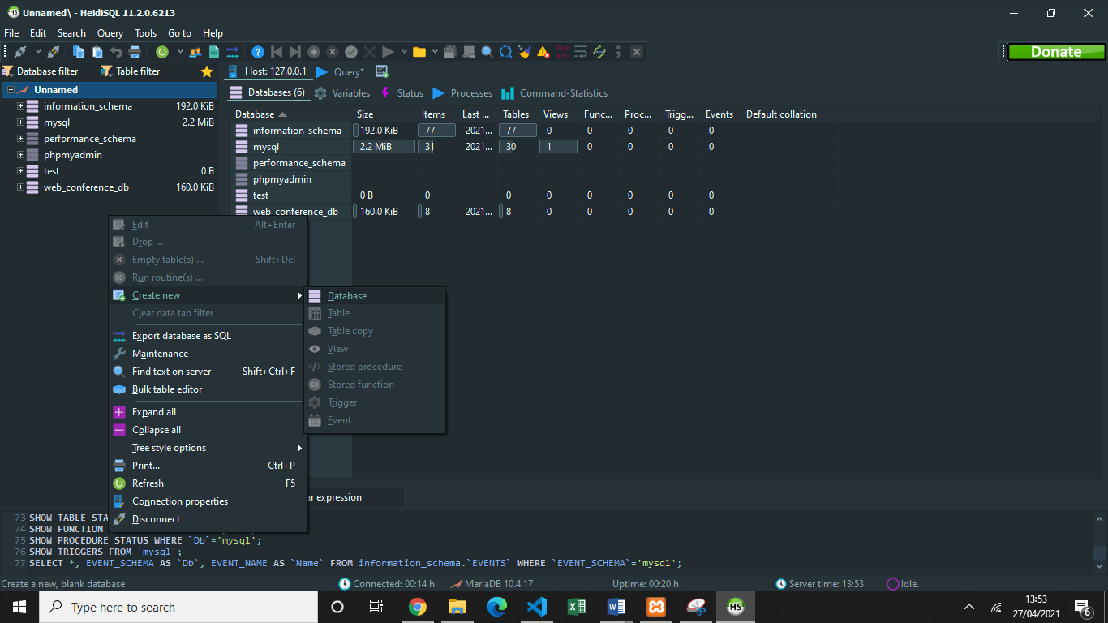

The database must have the same name as the field DB_DBNAME in the .env file, thus, naming the database ‘web_conference_db’ is suggested.

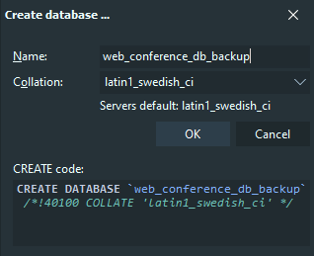

Once the database is created, the ‘Query’ tab of the database must be selected and right-clicked to select ‘Load SQL File’. The database dump ‘web_conference_db.sql’ file that is included in the submission must be used.

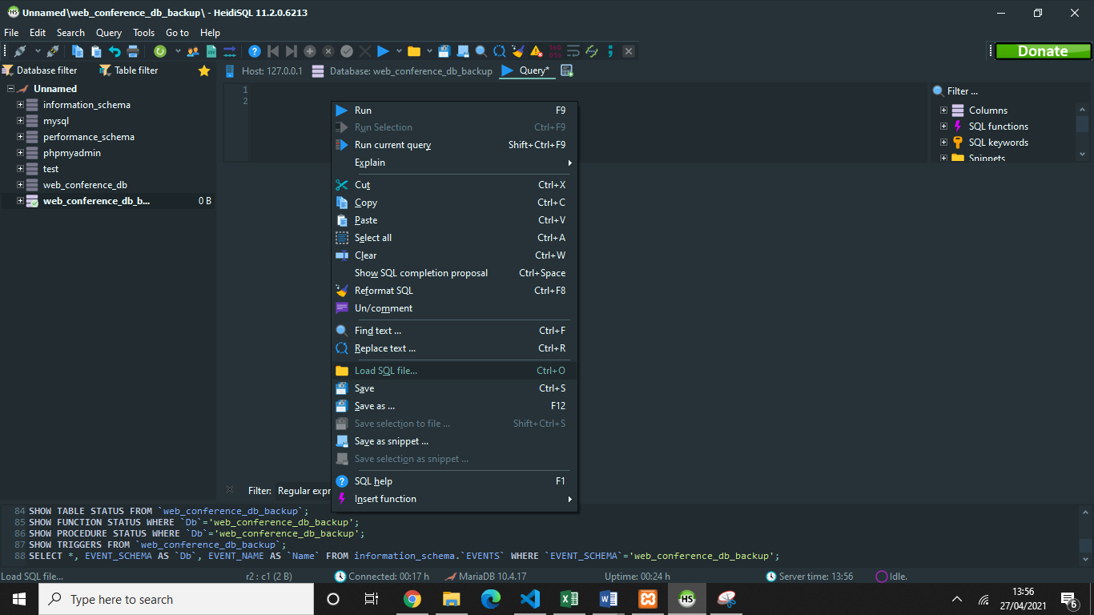

Once the file is selected, the query will show in the ‘Query’ field. The ‘Execute SQL’ option (Play Button) must be clicked once the Query is loaded. After a few seconds, the database must be refreshed by clicking the green ‘refresh’ button on the database.

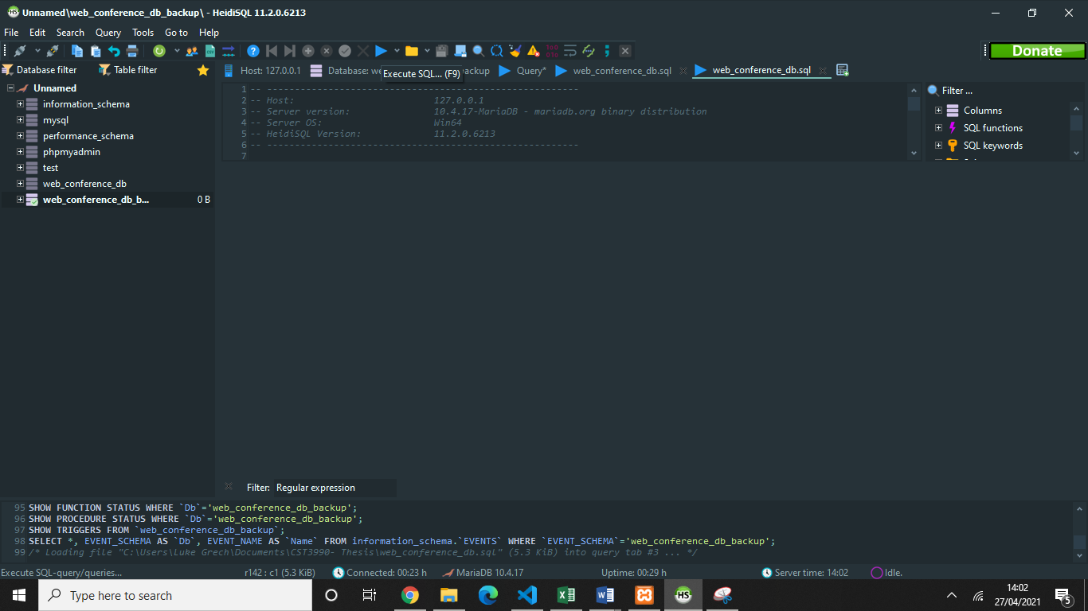

Once this process is completed the database should contain the same tables as below.

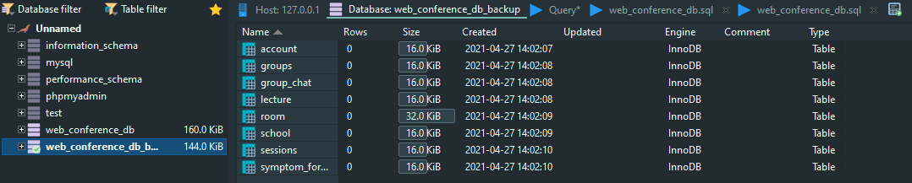

After setting up the database, the server may be started by navigating to the root directory folder of the app in Command Line/Powershell or opening a terminal in the file from the code editor and typing ‘npm start’ or ‘nodemon server.js’.

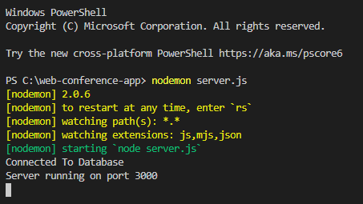

Once the server is started, the user must open Command Prompt and type ‘ipconfig’ to obtain the local IP address.

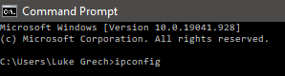



Once obtained, the IP address must be entered into the search bar of a browser to open the page in the form <https://ipaddress:3000>. The app may crash if the IP address of the device changes whilst being used, thus, the new IPv4 address must be used.

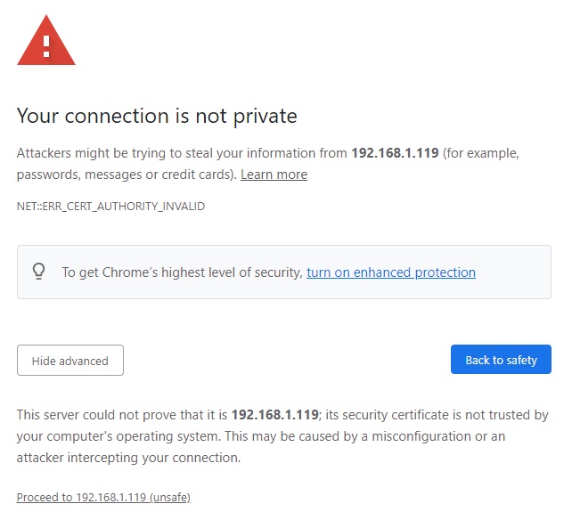

A warning will appear before using the app, which must be ignored by clicking the ‘proceed to the application’ link. This warning appears due to a self-signed SSL certificate, which is not signed by a certified authority due to the application being kept local. Once the link is clicked, the app will be opened.

